**Gmail Login page**

**Test scenarios:**

* Verify that "Email or phone" field is present on the page or not.
* Verify that Forgot Email link is present on page or not.
* Verify that Next button is present on page or not.
* Verify that Create Account link is present on the page or not.
* Verify that language (English) is present on the page or not.
* Verify the URL of the login page
* Verify that Help, Privacy, Terms are present on the login page or not.
* Verify that Tab key is working on page or not.

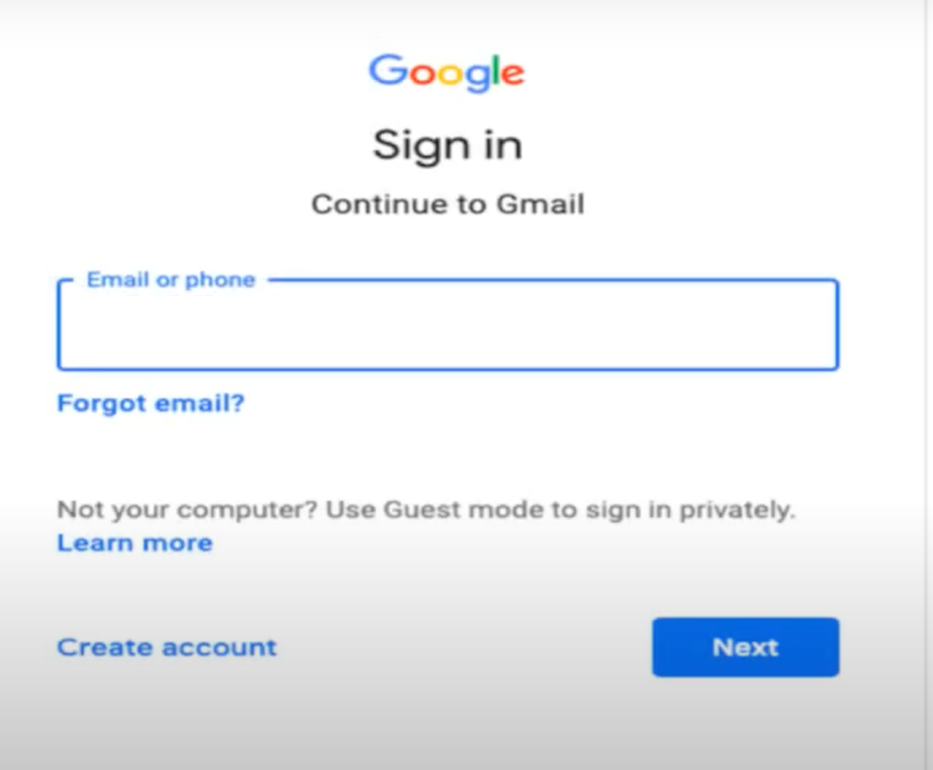

**Test Cases of "Email or Phone" field:**

* Verify that email or phone field is clickable.
* Verify that placeholder should be present in email field.
* Verify that user email should not start with any symbols.
* Verify the max length of the email field.
* Verify that email field should accepts alphanumeric values.
* Verify that if next button is pressed without entering the email. Error should be displayed.

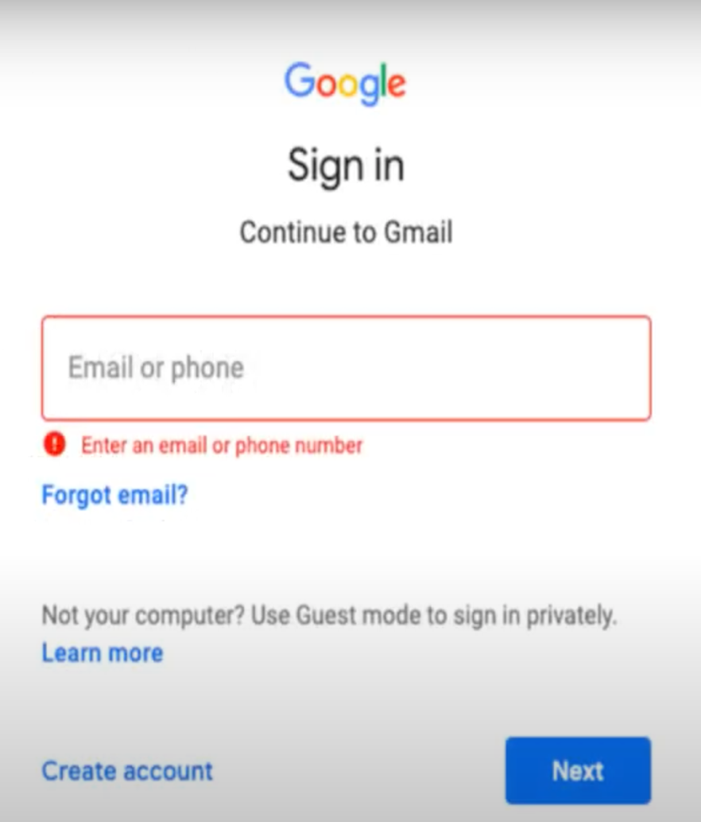

**Test Cases of "Password" field:**

* Verify that password field is clickable.
* Verify that placeholder is displayed in the password field.
* Verify the maximum and minimum length accepted in the password field.
* Verify that the password entered by user should be masked. a.com
* Verify that the password field should accept alphanumeric and symbols.
* Verify that any space in the beginning or end of password should be trimmed.
* Verify that error message is displayed when next button is pressed without password.

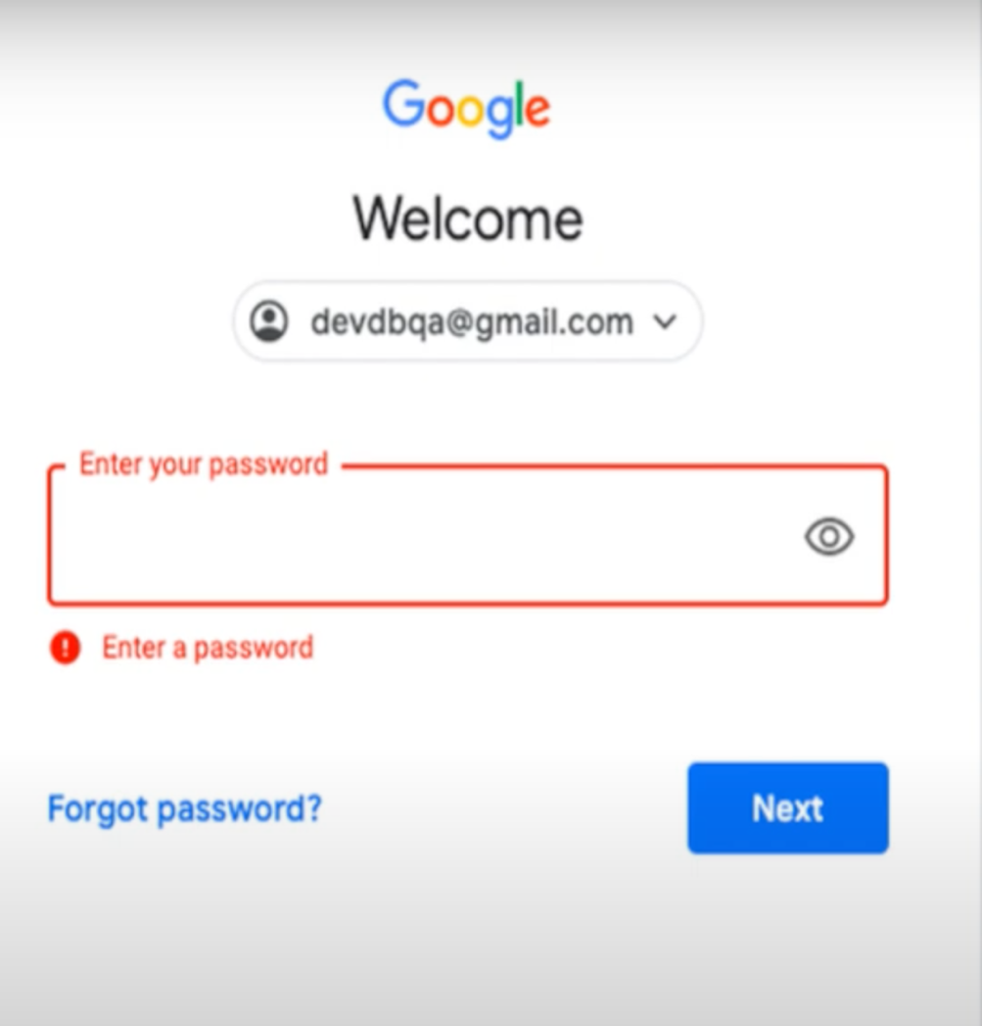

**Test Cases of "Forgot Email" functionality:**

* Verify that when forgot email is clicked user is redirected to find your email page.
* Verify that phone number or email field is present at Find your email page.
* Verify that next button is present on the page.
* Verify that email field should accept alphanumeric characters.
* Verify that when next button is pressed without entering the email, error message is displayed.
* Verify that when next button is pressed after entering valid email, user is redirected to What's your name page.
* Verify that First name and last name fields are present on What’s your name page.
* Verify that next button is present.
* Verify that when next button is clicked after entering invalid first and last name then error message is displayed.

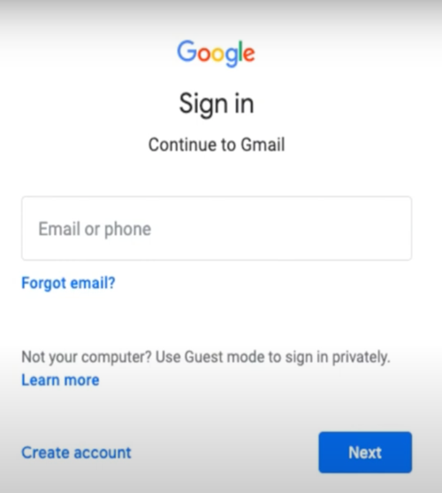 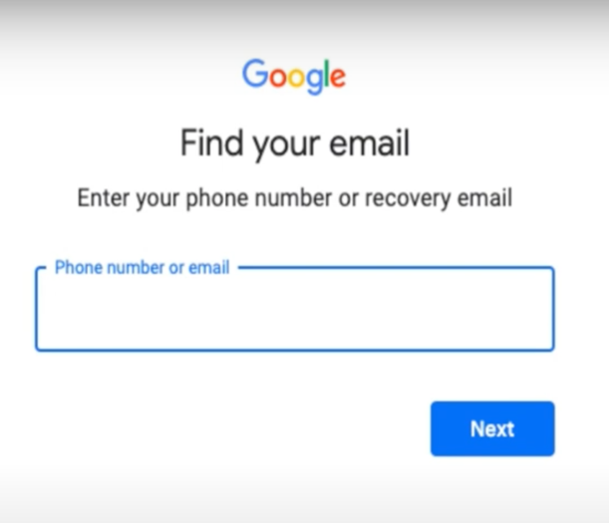

**Test Cases of "Forgot Password" functionality:**

* When user click on forgot password link, user should be redirected to Account Recovery page.
* Verify that user email address is displayed on the page.
* Verify that 'Enter last Password' field is present on the Account Recovery page.
* Verify that Next button is present on Account Recovery page,
* Verify that try another way is present on the Account Recovery page.
* Verify that when user enter invalid last password and press next button, error message is displayed.
* Verify that when user enter valid last password and press next button, reset password screen is displayed.
* Verify that password entered by user is masked.
* Verify that when user press on eye icon, the password entered by user is displayed in unmasked form.

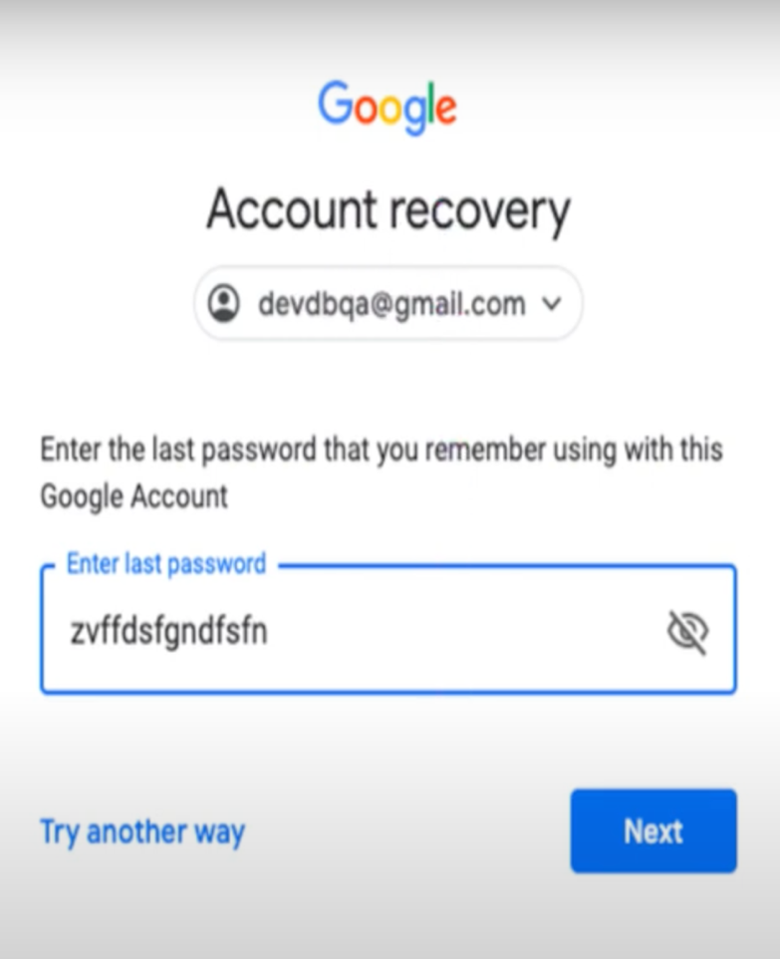

**Negative Test Cases:**

* Verify that User is able to Login with Valid Credentials
* Verify that User is not able to Login with invalid Username and invalid Password
* Verify that User is not able to Login with Valid Username and invalid Password
* Verify that User is not able to Login with invalid Username and Valid Password
* Verify that User is not able to Login with blank Username or Password
* Verify that account is is locked at or not when entering invalid password many times.
* Verify that user should not be able to login by swapping email and password.